CS 6327 Video Analytics

Exercise

**Description:**

Given an image I with various fruits (Fig. 1), please:

1. Create a brightness adjusted image B1 from the image I by adding a constant factor 50.
2. Convert both images from RGB to HSV color space. Write your own code to convert from RGB to HSV color space.
3. Find the “red apple” in each image using both of the following methods and mark the apple with a bounding circle/box . Methods to be used:

* Object detection **based on color** in RGB domain
* Object detection **based on color** in HSV domain

1. Convert the red apple into a green apple and vice versa.

NOTE: **Do not use built-in functions (in OpenCV/Matlab/or other tools)** for step 1 to 4 – operate on each pixel value.

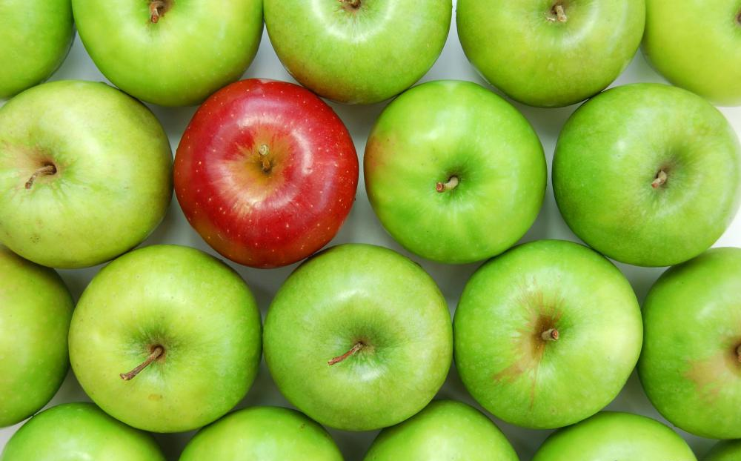

Figure 1: Images with various apples.

**Desired Output:**

Display **all** the intermediate results. For example,

*Birghtness adjusted image:*

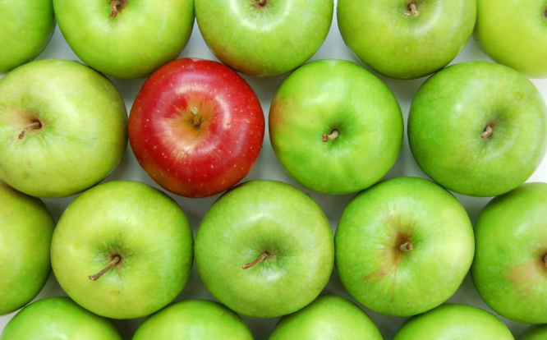 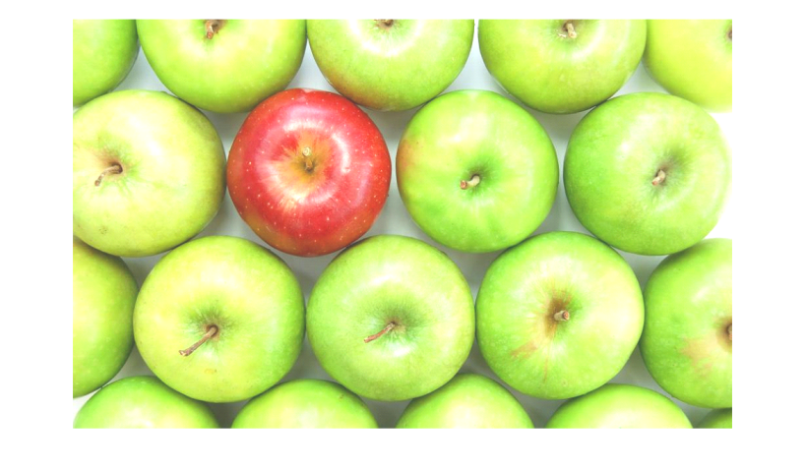

*RGB to HSV conversion:*

 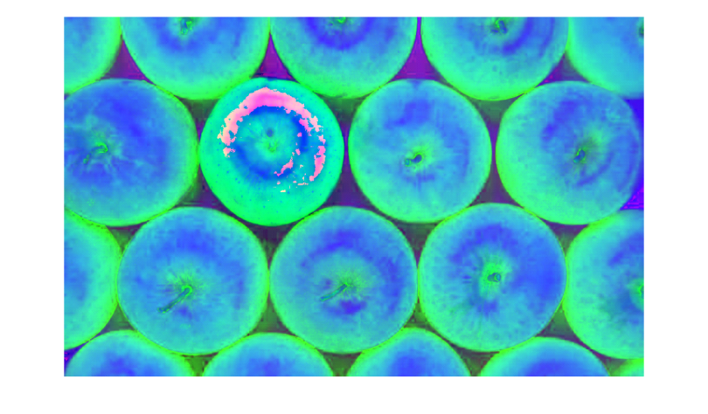

*Object detection based on color in HSV domain: (Show the result for all images)*

 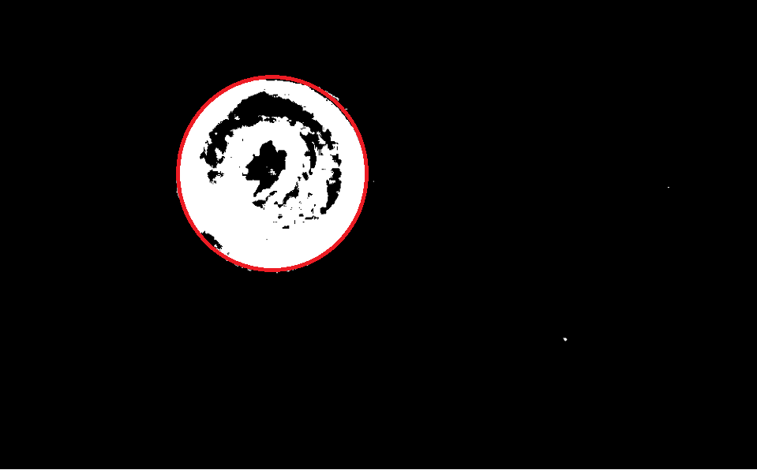

*Turing the red apple to green and vice versa*

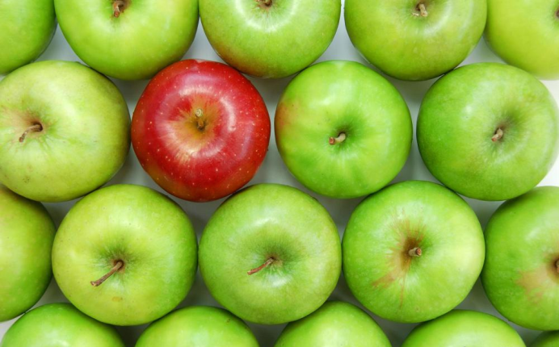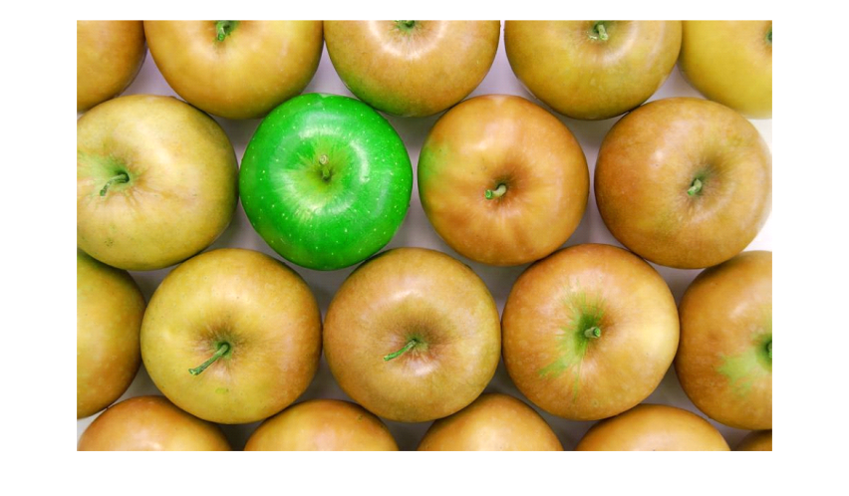

*These are few example of expected output. You need to show* ***all*** *the intermediate results.*